***Fatima bint Naseer***

***BSAI_3A_050***

**Mini project 1:**

This Python program stores movies with their budgets, finds the average budget, and lists movies that cost more than the average. Users can add new movies, and the program updates the list. It then shows the average budget and high-budget movies in a simple format.

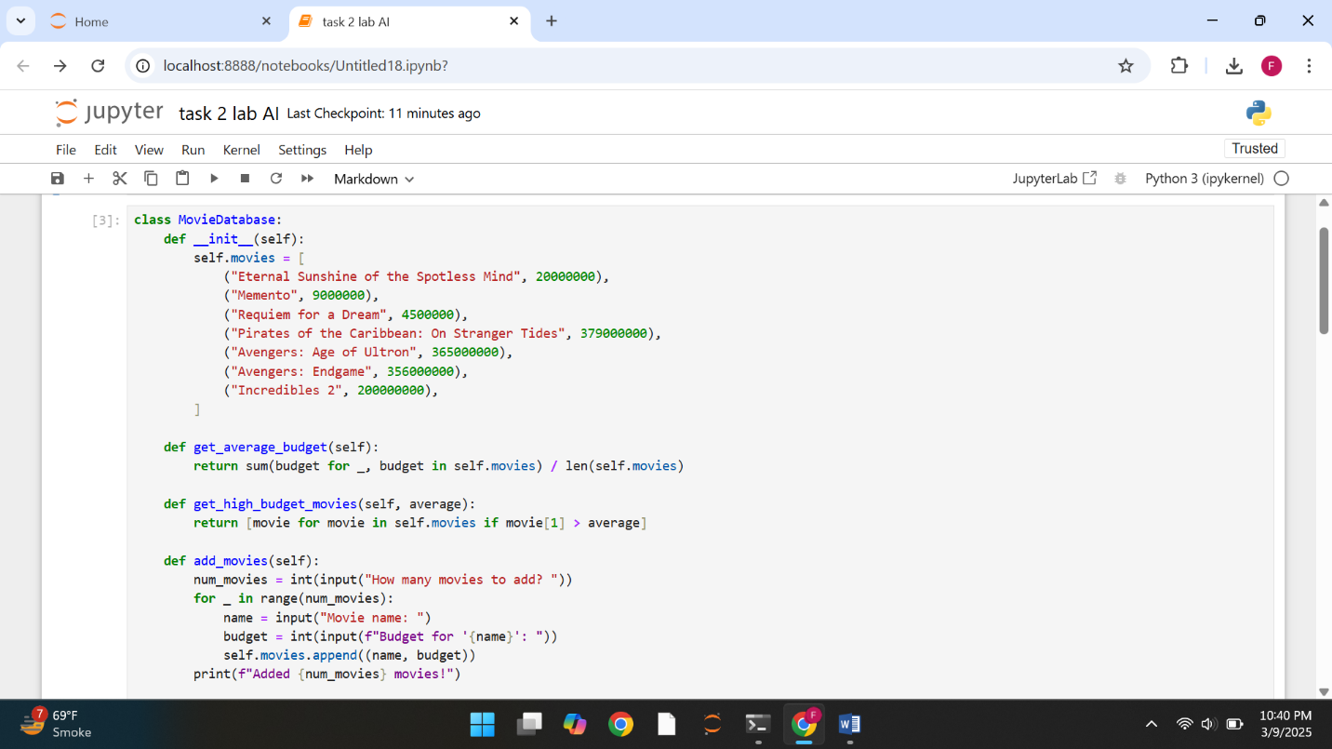

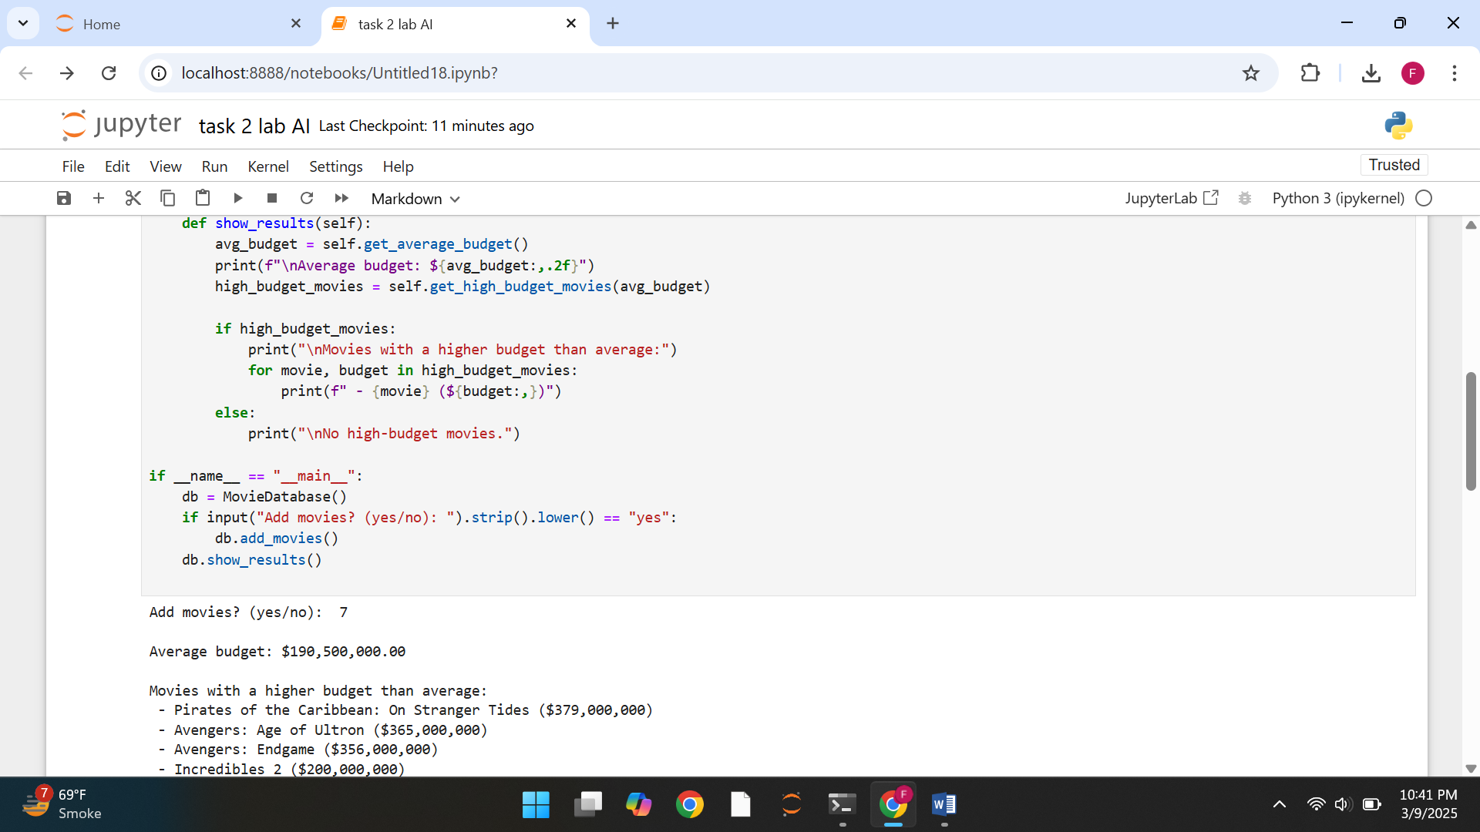

**Mini project 2:**

This Python program is a Fizz Buzz game where a random number between 3 and 40 is chosen in each round. The player decides how many rounds to play, and the program follows Fizz Buzz rules: "Fizz" for numbers divisible by 3, "Buzz" for those divisible by 5, and "FizzBuzz" for both. The game runs step by step and ends with a thank-you message.

